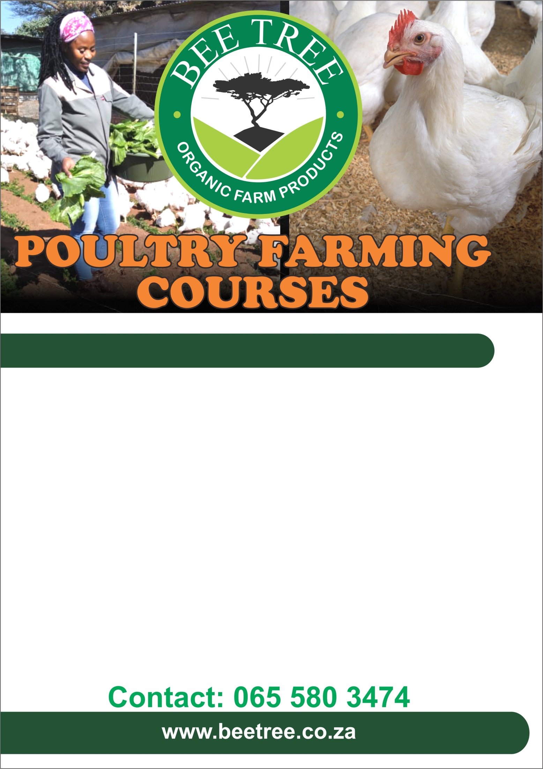
This training workshop will focus on the following topics:
Planning organic vegetable production
Soil preparation using organic methods
Planting and crop maintenance practice
Disease management using organic methods
Harvesting
Marketing your produce

This course is suitable for anyone who would like to start vegetable production for business or for home consumption for their families

Date: 3 February 2024
Time: 9am - 5pm
Venue: Bee Tree Farm

Cost R1500
(Incl. Coffee, Farm lunch, Practical’s, Training module and Certificate of attendance)
Sustainable , Environment-friendly Vegetable production Workshop

